**Excel Assignment – 10**

**Q1: See the below picture and create the exact table with exact formatting .Font – ‘Times New Roman’ Size – 14, Color of first line Orange.**

Ans : 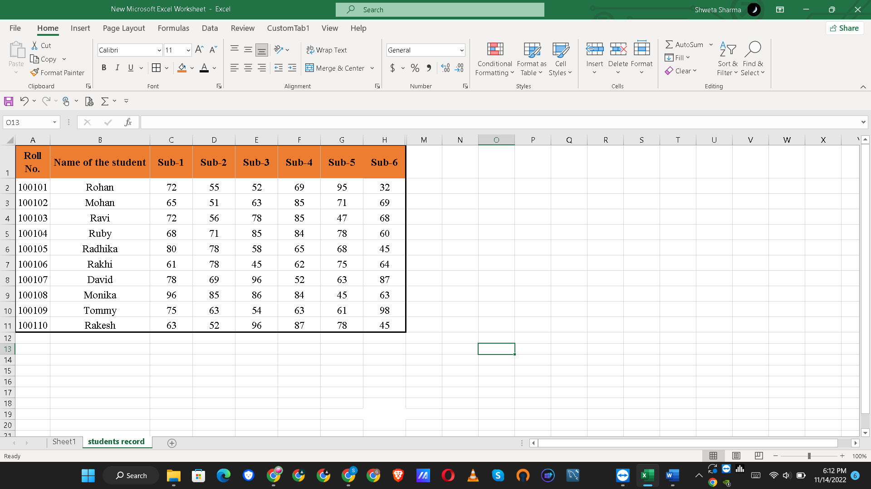

**Q2: From the above table use Sum Formula and find the total for each student.**

Ans: 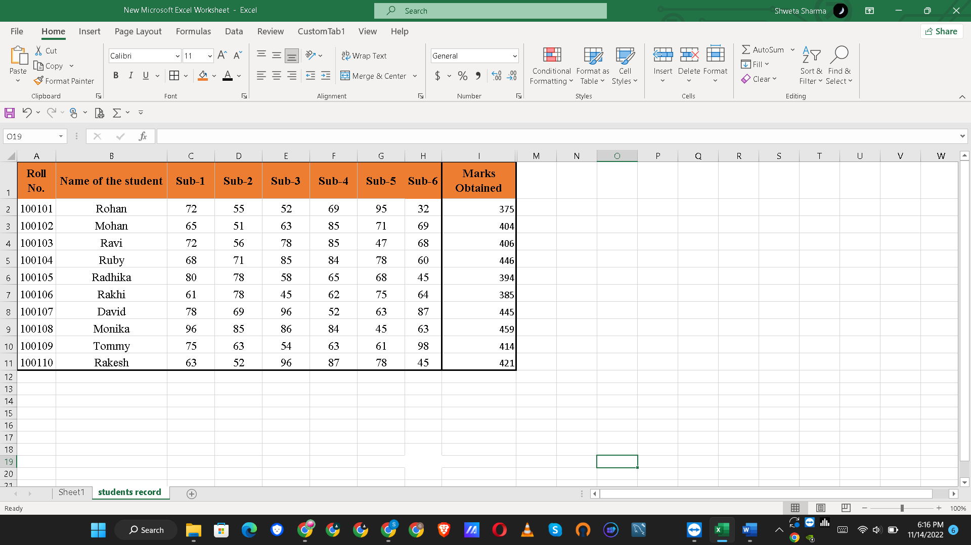

**Q3: Calculate Average for each student in the next row. Use Formulas.**

Ans: 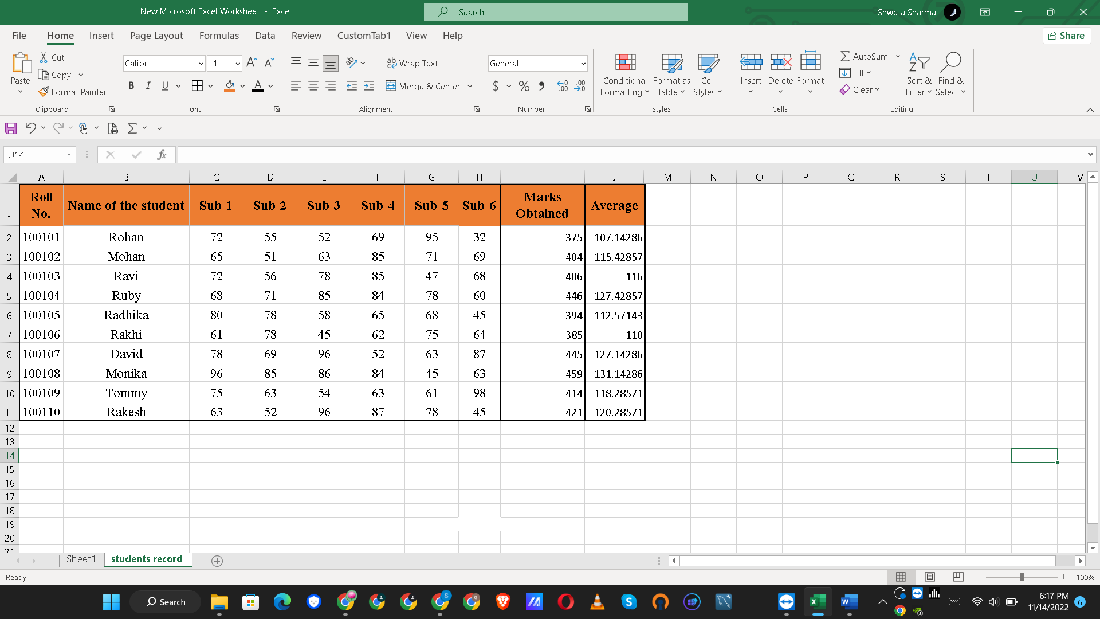

**Q4: Calculate Rank for each student. Use Formulas.**

Ans: 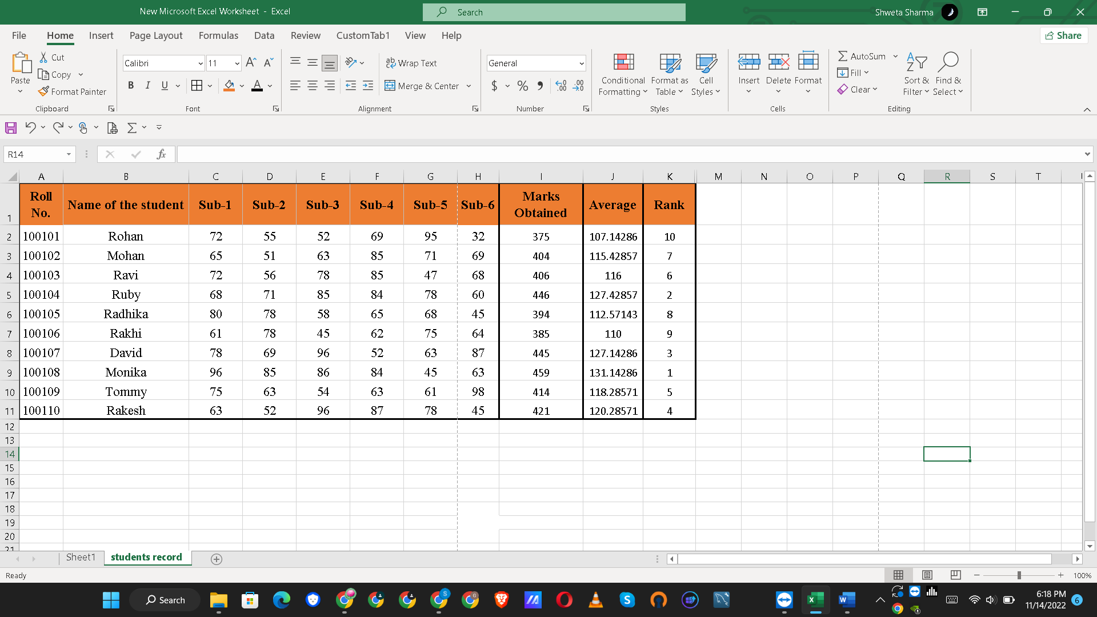

**Q5: Calculate Percentage for each student. Use Formulas. Round off the decimals up to 2 points.**

Ans: 